**OBJECT ORIENTED CONCEPT & PROGRAMMING**

**(SE-201) LAB-6**

**TAQI HAIDER_CSIT_SECTION:B_ROLL#CT-22092**

**Exercise:-**

**Q1:-**

#include <iostream>

using namespace std;

class rectangle {

    float length, width, area, parameter;

public:

    rectangle() : length(0), width(0) {}

    void setData(float len, float wid) {

        length = len;

        width = wid;

    }

    void calculateArea() {

        area = length * width;

    }

    void calculateParameter() {

        parameter = 2 * (length + width);

    }

    float getArea() const {

        return area;

    }

    float getParameter() const {

        return parameter;

    }

    void display() {

        cout << "Area Of Rectangle is: " << getArea() << endl;

        cout << "Parameter of Rectangle is: " << getParameter() << endl;

    }

};

class dormRoom {

    int room_no;

    int capacity;

    bool isOccupied;

public:

    dormRoom(int x, int y) : room_no(x), capacity(y), isOccupied(false) {}

    int getRoomNumber() const {

        return room_no;

    }

    int getRoomCapacity() const {

        return capacity;

    }

    void occupy() {

        isOccupied = true;

        cout << "Room is occupied: " << isOccupied << endl;

    }

    void vacate() {

        isOccupied = false;

        cout << "Room is occupied: " << isOccupied << endl;

    }

};

int main() {

    rectangle r1;

    float len, wid;

    cout << "Enter Length Of Rectangle: ";

    cin >> len;

    cout << "Enter Width Of Rectangle: ";

    cin >> wid;

    r1.setData(len, wid);

    r1.calculateArea();

    r1.calculateParameter();

    r1.display();

    cout << endl;

    cout << "Dorm Room Information:" << endl;

    dormRoom d1(5, 3);

    cout << "Room Number:  " << d1.getRoomNumber() << endl;

    cout << "Room Capacity: " << d1.getRoomCapacity() << endl;

    d1.occupy();

    d1.vacate();

    return 0;

}

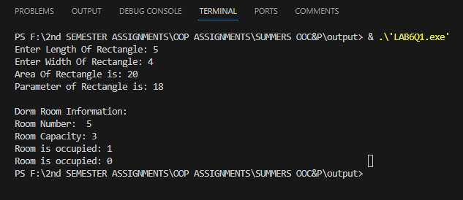

**Q2:-**

#include <iostream>

using namespace std;

class mealBill

{

    float meal_bill,sales_tax,Total_bill,payment,change;

    string restaurant_name;

public:

    mealBill(string x) : restaurant_name(x)

    {

        cout << "Enter Meal Bill: ";

        cin >> meal_bill;

    }

    void bill()

    {

        cout << "Bill" << endl;

        cout << "\tMeal Bill: " << meal_bill << endl;

        sales_tax = (meal_bill * 0.16); // sale tax is 16%

        cout << "\tTax: " << sales_tax << endl;

        cout << "\tTip: " << (meal_bill * 0.15) << endl;

        Total_bill = meal_bill + sales_tax + (meal_bill * 0.15);

        cout << "\tTotal cost: " << Total_bill << endl;

        cout << endl;

    }

    void receipt()

    {

        cout << "Enter Payment Paid: ";

        cin >> payment;

        cout << "Receipt" << endl;

        cout << "\t Total cost: " << Total_bill << endl;

        cout << "\t Payment: " << payment << endl;

        change = payment - Total_bill;

        cout << "\t Change: " << change << endl

             << endl;

        cout << "\t Thank you for dining at " << restaurant_name << endl;

    }

};

int main()

{

    mealBill customer("Taqi_Haider");

    customer.bill();

    customer.receipt();

    return 0;

}

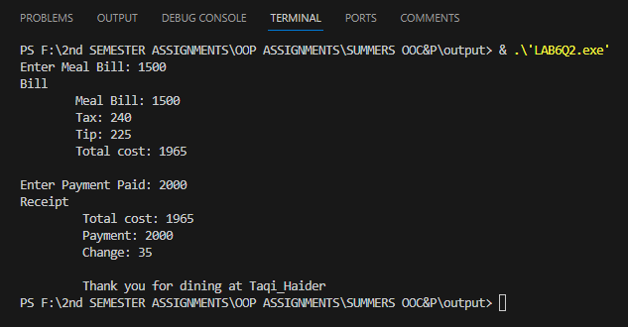

**Q3 :-**

#include <iostream>

using namespace std;

class management_system

{

    float meal_bill;

    float sales_tax;

    float Total_bill;

    float payment;

    float change;

    float current_balance;

    string name;

    string Student_Id;

public:

    management_system(float u, string v, string w) : current_balance(u), name(v), Student_Id(w)

    {

        cout << "Enter Meal Bill: ";

        cin >> meal_bill;

    }

    void bill()

    {

        cout << "Bill" << endl;

        cout << "\tMeal Bill: " << meal_bill << endl;

        sales_tax = (meal_bill * 0.06); // sale tax is 16%

        cout << "\tTax: " << sales_tax << endl;

        cout << "\tTip: " << (meal_bill * 0.15) << endl;

        Total_bill = meal_bill + sales_tax + (meal_bill * 0.15);

        cout << "\tTotal cost: " << Total_bill << endl;

        cout << endl;

    }

    void updateBalance()

    {

        current_balance = current_balance + Total_bill;

        current_balance = current_balance - payment;

    }

    void receipt()

    {

        cout << "Charger the meal to " << name << "'s account \n" << endl;

        cout << "Enter Payment Paid: ";

        cin >> payment;

        updateBalance();

        cout << "Receipt" << endl;

        cout << "\t Total cost: " << Total_bill << endl;

        cout << "\t Payment: " << payment << endl;

        if (payment == 0)

        {

            change = payment;

        }

        else

        {

            change = payment - Total_bill;

        }

        cout << "\t Change: " << change << endl

             << endl;

        cout << "\t Thank you for dining at University Summit " << endl;

        cout<<endl;

    }

    void showStudentData()

    {

        cout << "Current Status of Ahmed's account:" << endl;

        cout << "ID: " << Student_Id << endl;

        cout << "Name: " << name << endl;

        cout << "Balance: " << current_balance << endl;

    }

};

int main()

{

    management_system Ahmed_Ali(2000, "Ahmed", "CT-22092");

    Ahmed_Ali.bill();

    Ahmed_Ali.receipt();

    Ahmed_Ali.showStudentData();

    return 0;

}

